Project Design Phase-II
Data Flow Diagram & User Stories

Date | 30-09-2026
Team ID | SWTID-2026-3179
Project Name | AI-Augmented Backend Development AI FitTrack API
Maximum Marks | 4 Marks

Data Flow Diagrams:
A Data Flow Diagram (DFD) is a traditional visual representation of the information flows within a system. A neat and clear DFD can depict the right amount of the system requirement graphically. It shows how data enters and leaves the system, what changes the information, and where data is stored.
Level 0 DFD - AI FitTrack Backend API:
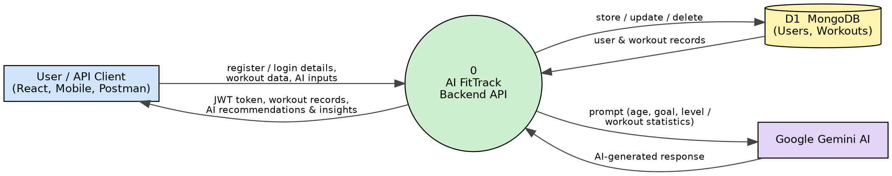
Level 1 DFD - AI FitTrack Backend API:
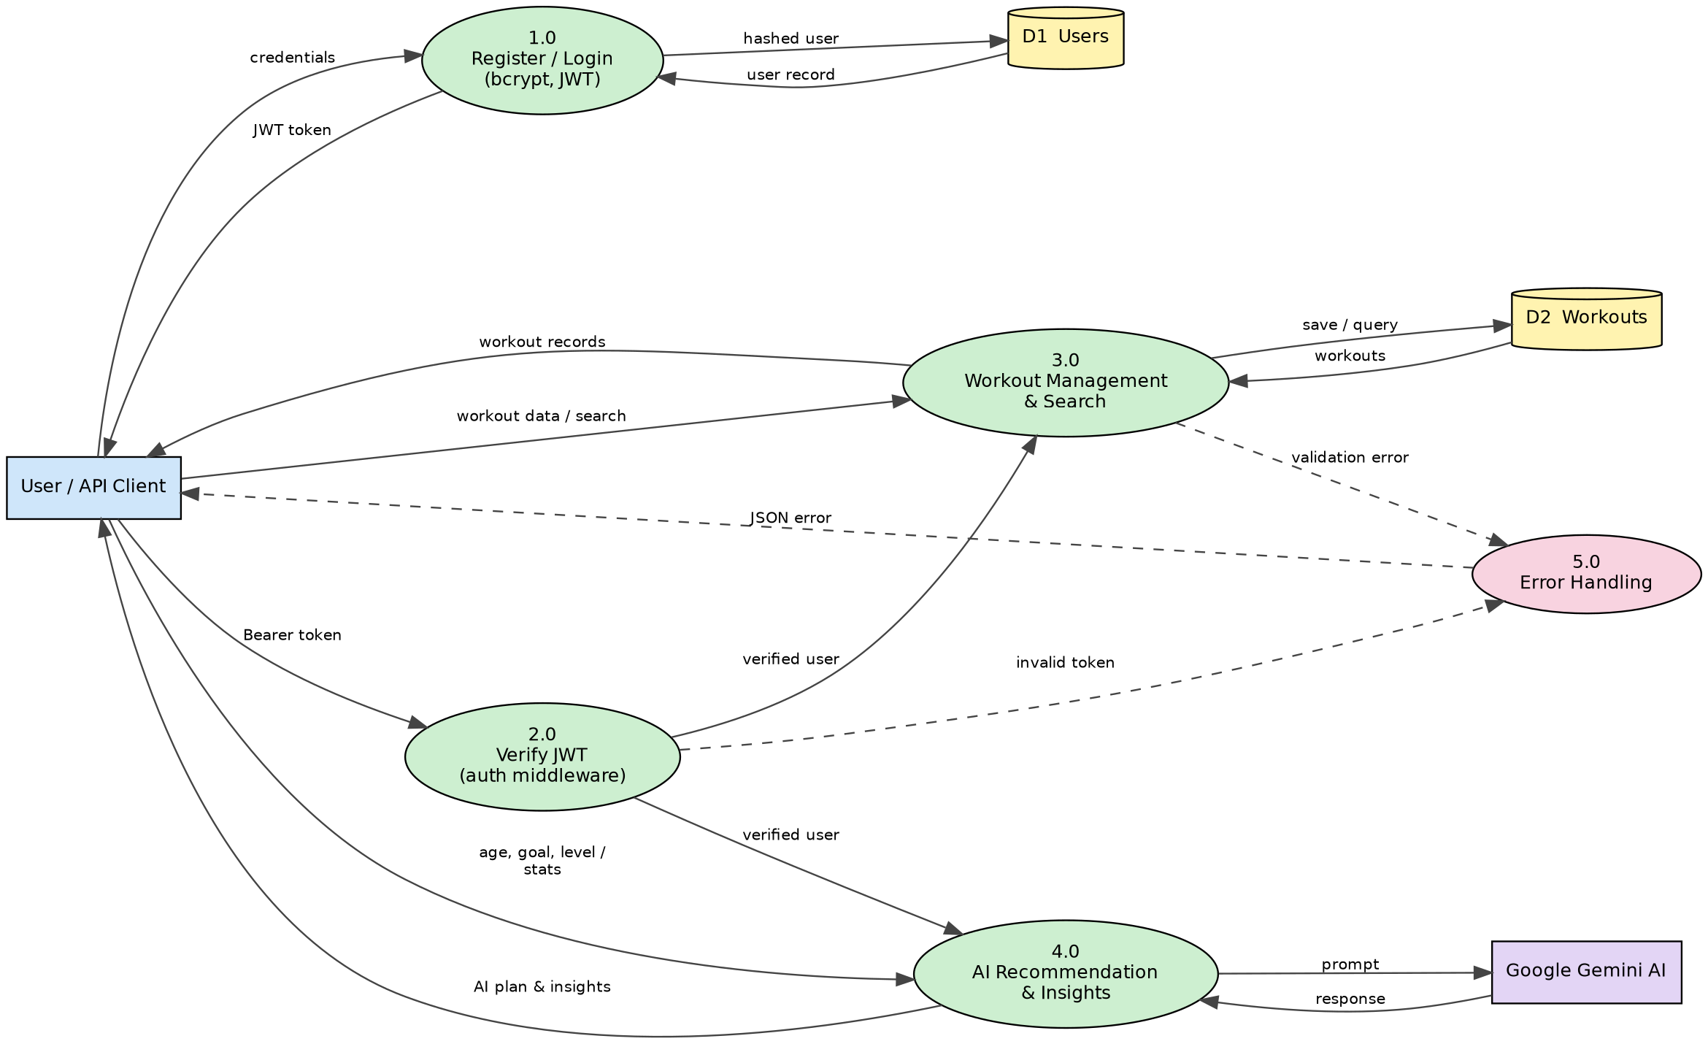

User Stories
Use the below template to list all the user stories for the product.
User Type | Functional Requirement (Epic) | User Story Number | User Story / Task | Acceptance criteria | Priority | Release
Authenticated User | Registration | USN-1 | As a user, I can register with my name, email and password. | Account is created (201) and the password is stored hashed | High | Sprint-1
 | Login | USN-2 | As a user, I can log in with my email and password. | I receive a JWT token and my user details (200) | High | Sprint-1
 | Profile | USN-3 | As a user, I can view my profile. | Valid token returns my id, name and email (200) | Medium | Sprint-1
 | Workout Management | USN-4 | As a user, I can add a workout with name, category, duration, calories and date. | Workout is saved against my account (201) | High | Sprint-2
 | Workout Management | USN-5 | As a user, I can view all my workouts. | Response returns a count and array of my workouts (200) | High | Sprint-2
 | Workout Management | USN-6 | As a user, I can get a workout by ID. | The matching workout is returned (200) | Medium | Sprint-2
 | Workout Management | USN-7 | As a user, I can update a workout. | Updated workout is returned (200) | Medium | Sprint-2
 | Workout Management | USN-8 | As a user, I can delete a workout. | "Workout removed successfully" is returned (200) | Medium | Sprint-2
 | Workout Search | USN-9 | As a user, I can search workouts by name, category or date. | Only matching workouts are returned | Medium | Sprint-2
 | AI Workout Recommendation | USN-10 | As a user, I can submit my age, fitness goal and experience level to get a personalised workout plan. | A workout recommendation with tips and safety advice is returned (200) | High | Sprint-3
 | AI Fitness Insights | USN-11 | As a user, I can submit my workout statistics to get fitness insights. | Personalised insights and suggestions are returned (200) | High | Sprint-3
 | Error Handling | USN-12 | As a user, I receive clear JSON errors when my request is invalid or unauthorised. | Missing/invalid token returns 401; validation errors return a descriptive message | High | Sprint-4

